Secondary School Developmental Needs
High school is the final transition into adulthood and the world of work as students begin separating from parents and exploring and defining their independence. Students are deciding who they are, what they do well, and what they will do when they graduate. During these adolescent years, students are evaluating their strengths, skills and abilities. The biggest influence is their peer group. They are searching for a place to belong and rely on peer acceptance and feedback. They face increased pressures regarding risk behaviors involving sex, alcohol and drugs while exploring the boundaries of more acceptable behavior and mature, meaningful relationships. They need guidance in making concrete and compounded decisions. They must deal with academic pressures as they face high-stakes testing, the challenges of college admissions, the scholarship and financial aid application process and entrance into a competitive job market.

Meeting the Challenge
Secondary school counselors are professional educators with a mental health perspective who understand and respond to the challenges presented by today’s diverse student population. Secondary school counselors do not work in isolation; rather they are integral to the total educational program. They provide proactive leadership that engages all stakeholders in the delivery of programs and services to help the student achieve success in school. Professional school counselors align and work with the school’s mission to support the academic achievement of all students as they prepare for the ever-changing world of the 21st century.

School Counselors…

- Implement effective classroom guidance

- Provide individual and small group counseling

- Provide assessment by helping students identify their skills, abilities, achievements and interests

- Develop student’s career awareness

- Coordinate school, community, and business resources

- Provide consultation with teachers, school staff, and outside agencies

- Make Appropriate referrals for special services for students

North Sand Mountain High School
Counseling Department

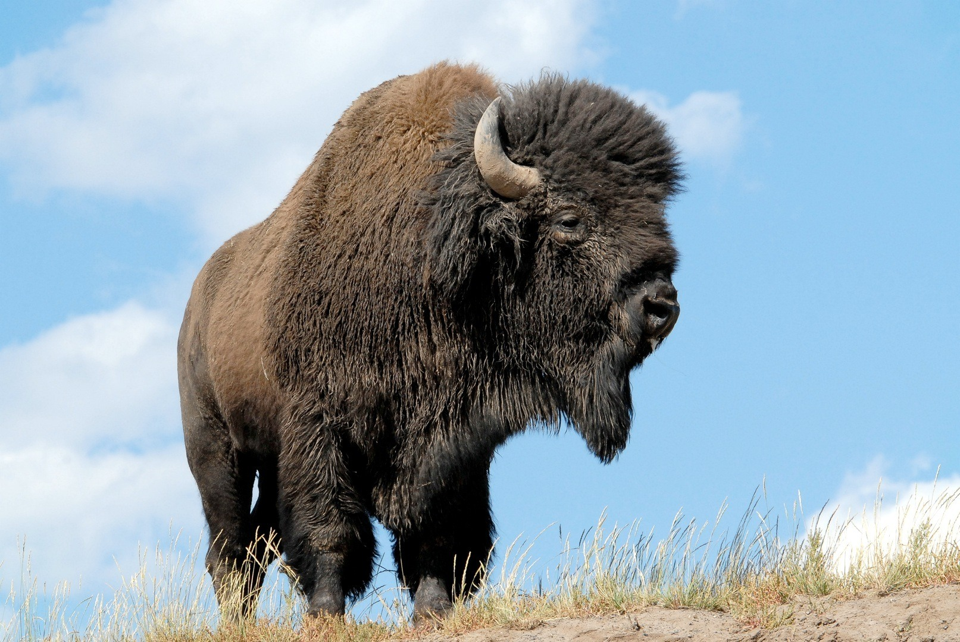

Home of The Bison

Mr. Chris Davis, Principal
Mrs. Angie Bain, Counselor
Mrs. Danielle Maples, Counselor

256-597-2368

SOCIAL DEVELOPMENT

Counselors help students to…

- Develop feelings of adequacy
- Learn ways to resolve inter-personal relationships
- Establish sound family relationships
- Establish effective working relationships with teachers and administrators
- Respect individual differences and cooperate with others.

CAREER DEVELOPMENT

Counselors help students to…

- Analyze personal interests, aptitude,
and skills
- Recognize effects of career stereotyping
- Form a career identity
- Be aware of career choices and opportunities
Discuss educational standards that meet career goals,

Counselors Provide Services Through Four Components…

Guidance Counseling

Provides guidance content in a systematic way to all students

Individual Counseling

Assists students in planning, monitoring, and managing their personal and career goals.

Responsive Services

Addresses the immediate concerns of students

System Support

Includes program, staff, and school support activities and services.

For many students, the school counselor may be the one person who provides an atmosphere of safety, trust, and positive regard.
COUNSELORS WORK WITH STUDENTS IN FOUR DIFFERENT ESSENTIAL AREAS

PERSONAL DEVELOPMENT
Counselors help students to…

- Gain self-awareness
- Improve self-esteem
- Develop attitudes and actions necessary to achieve success
- Make healthy choices and effective decisions
- Accept responsibility
- Learn to resolve conflicts and assume responsibility for personal behavior

EDUCATIONAL DEVELOPMENT
Counselors help students to…

- Acquire study and test-taking skills
- Seek and use educational information
- Set educational goals
- Make appropriate educational choices
- Develop educational plans that relate to their interests, abilities, achievements, and needs.

