9/26/2023

Parents/Guardians,

Every year, we complete a needs assessment for our school to determine how we need to improve. To get a true picture of how we are doing, we need your input. To share your opinion, please use the QR code or the link below to take the Parent/Guardian survey for this year’s needs assessment.

It is very important that on the first screen, you do NOT select Jackson County Board of Education. Please select **Hollywood Elementary School**.

After you complete the survey, please sign and return this form to your child’s teacher. Each student will receive a special reward which has been determined by each homeroom teacher. The survey will be open until October 5.

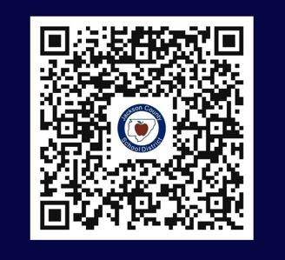Thank you for working with us to make improvements to our school.

<https://eprovesurveys.advanc-ed.org/surveys/#/action/231377/p1429>

Student Name:__________________________________________________

Parent/Guardian Signature:________________________________________